FOR IMMEDIATE RELEASE
February 15, 2019 | Greenbrae, California
Visit www.dennisportnoy.com for contact details, review copies, photos, and an author bio.
New Book by San Francisco Psychotherapist Addresses
Pervading Anxiety and Lack of Fulfillment in Our Society

Defining ourselves by our performance and usefulness is causing us to feel anxious and unfulfilled

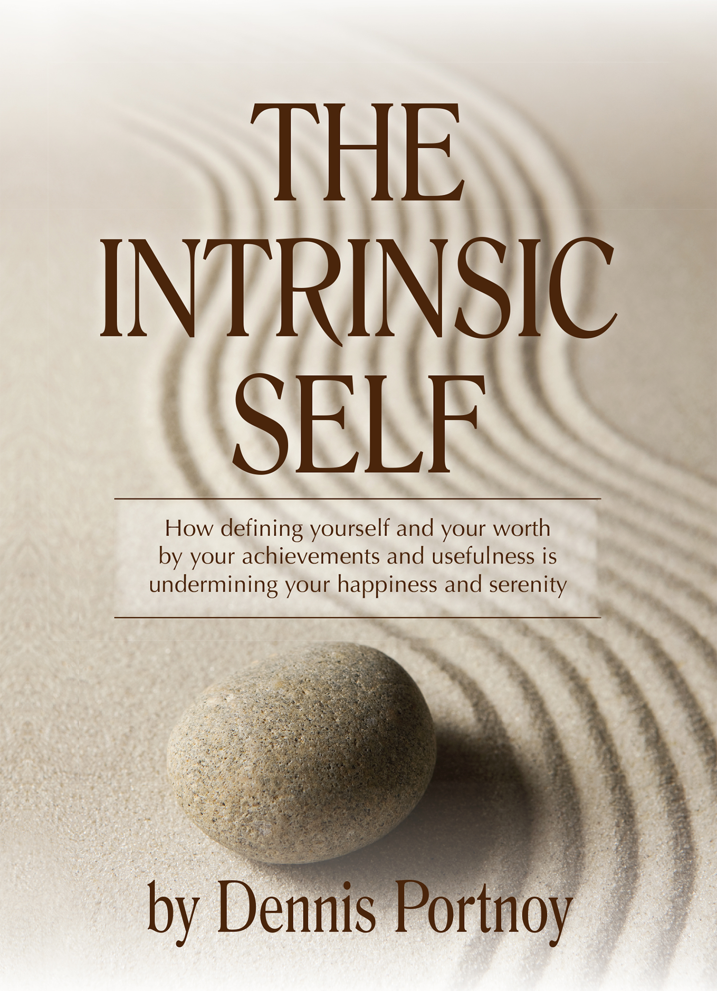
What if everything you’ve been telling yourself about being caring, successful and competent contributes to your stress and unhappiness? What if these very qualities that you view as virtuous and necessary to succeed in the world are keeping you disconnected from yourself?
THE INTRINSIC SELF: How Defining yourself and your Worth by your Achievements and Usefulness is Undermining your Happiness and Serenity, written by Dennis Portnoy, will be available June 1, 2019 on Amazon.
Defining ourselves, and our worth, by what we do rather than who we are, and by how others view us, often lies at the heart of our distress and emotional struggles, advises Dennis Portnoy, a psychotherapist for over 30 years.
Disconnected from our Intrinsic worth fosters an externally driven mindset that permeates our culture, making us intolerant of our shortcomings, preoccupied with “fitting in,” and forever seeking external validation in order to feel adequate.
We learn to make choices based on others expectations rather than being guided by our internal compass. Moving beyond simply increasing self-esteem, The Intrinsic Self teaches us to affirm our true value, and form a self-concept that doesn’t revolve primarily around performance and usefulness to others’.
Dennis Portnoy is a psychotherapist with more than 30 years experience, as well as a published author, and a speaker and seminar leader. When he is not working with clients, giving presentations or writing, he trains and rides horses.
For more info, visit www.dennisportnoy.com or call 415-816-5858

